1/30/15 Basic Chemistry

Blood

1. What compounds are in blood?
2. Why is blood a mixture?
3. What is the acceptable pH range for blood?
4. How is this maintained?
5. When pH levels lower dangerously, acidosis results. This
happens when acids build up or bicarbonate ions are lost.
Give causes for each of the following reasons acids build up:
- too much carbon dioxide (ie. Can’t get rid of enough CO2)
- kidney can’t remove acids (ketoacidosis)
- lactic acid build up
Give a cause for losing too much sodium bicarbonate
(hyperchloremic acidosis)
6. How does the body react when acidosis results?
7. When pH levels rise dangerously, alkalosis results. Give causes
for the following reasons of alkalosis:
- too little CO2
- too little chlorine
*c. lack of oxygen = high altitudes
8. How does the body react when alkalosis results?

Biochemistry: Inorganic and Organic Chemistry
- Inorganic

- Water –

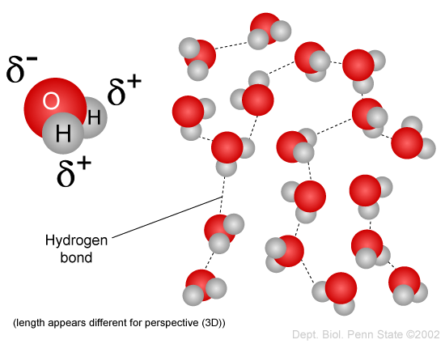

- Salts –
- Acids – already in notes
- Bases – already in notes
- Oxygen – already in notes

