Ecology cont’d

Food Chain, Food Web, Energy Pyramids – Energy Transfer thru an Ecosystem ----

1. Complete reading and watching the videos on Discoveryeducation
2. Complete the lab below: Oh What a Tangled Web We Weave

___________

Lab Worksheet: Oh, What a Tangled Web We Weave
Background:

Plants use light energy of the sun to make food. The food is stored in the cells of the plant. Plants are called producers because they make food. Some of the stored energy in the food plants make is passed on to the animals that eat the plants. Plant-eating animals are called primary consumers. Animals that eat other animals are called secondary consumers.
The pathway that food takes through an ecosystem is called a food chain. A food chain also shows the movement of energy from plants to plant eaters and then to animal eaters. An example of a food chain can be written:

seeds sparrow hawk

Some of the food energy in the seeds moves to the sparrow that eats them. Some of the food energy then moves to the hawk that eats the sparrow. Normally, only about 10% of the energy produced by the “food” moves to the consumer. Most of the other energy is used to keep the organism alive and allow it to reproduce.
Because a hawk eats animals other than sparrows, you could make a food chain for each animal the hawk eats. If all the food chains were connected, the result is a food web. A food web is a group of connected food chains. A food web shows many energy relationships.

Goals:

In this exercise, you will:
- determine what different animals eat in several food chains.
- build a food web that could exist in a forest ecosystem.
- identify how a food chain can be shown as a food pyramid.

Materials:

Colored pencils (red, blue, green and yellow)
Set of “organisms”

Procedure:

Part A. Examining Food Chains
A. Study the food chains listed below and at the top of the next page.
B. Complete the table on the next page. Checkmark or “X” all the things that each animal listed on the
left side eats.
plant parts land snail mouse raccoon
plant parts sparrow hawk
plant parts rabbit fox
plant parts mouse fox
plant parts earthworm robin snake
plant parts raccoon fox
plant parts rabbit snake
plant parts cricket robin fox
plant parts earthworm snake hawk fox
plant parts rabbit hawk
plant parts small insects mouse owl
plant parts rabbit owl fox
plant parts cricket mouse hawk
plant parts mouse snake owl

Food in an Ecosystem
Animals in a Forest Ecosystem | Living Things the Forest Animals Eat
 | Cricket | Earthworm | Hawk | Insects  (small) | Land snail | Mouse | Owl | Plants | Rabbit | Raccoon | Robin | Snake | Sparrow
Cricket
Earthworm
Fox
Hawk
Insects (small)
Land snail
Mouse
Owl
Rabbit
Raccoon
Robin
Snake
Sparrow

Part B: Making a Food Web
A. Use the information in the food chains given on pp. 1-2 to complete the diagram on the next page.
Draw an arrow from each living thing below to each thing that eats it. The first arrow in any food chain
(between producer and primary consumer) should be green, the second (between primary consumer
and secondary consumer) should be blue, the third (between secondary and tertiary consumer) should
be red and the fourth should be yellow. Also, draw your lines so they bend around the animal names.
This will make your food web easier to read when you finish.

Questions:

1. In how many food chains do the following animals appear?

hawk _____ earthworm _____ fox _____
owl _____ snake _____ small insects _____

2. In how many food chains do plants (parts) appear? _______

3. List the names of the living things in this forest ecosystem that are producers. ____________________
___________________________________________________________________________________

4. List those things that are only primary consumers. __________________________________________
___________________________________________________________________________________

5. What is another name for an animal that is only a primary consumer? ___________________________

6. List those things that are only secondary consumers_________________________________________
___________________________________________________________________________________

7. What is another name for an animal that is only a secondary consumer? _________________________

8. List the consumers that eat both plants and animals. _________________________________________
___________________________________________________________________________________

9. What is another name for an animal that eats both plants and animals? __________________________

10. What would happen to the food web if all the plants were removed? ___________________________
_________________________________________________________________________________

Explain your answer.__________________________________________________________________
___________________________________________________________________________________

11. Describe how 3 animals might be affected if owls were removed from the food chain. _____________
___________________________________________________________________________________

12. Draw three food chains showing producers and consumers that you might see in your backyard or on
your way to school. (You may use words or drawings.)
__________________________________________________________________________________

__________________________________________________________________________________

__________________________________________________________________________________

13. Since only 10% of the energy produced by a level in a food chain is passed on to its predator, there
have to be many more “prey” than “predators”. Draw a food pyramid of the first food chain listed in
Part A. Remember that there are more producers than primary consumers, more primary consumers
and secondary consumers, etc.

14. If 2000 kcal of energy are available in grass, how much energy would be available to the cow that eats
the grass? To the human that eats the cow?

15. Which organism in this food web has the greatest influence on the ecosystem? Justify your answer.

Water Cycle – understand how a drop of water can move
through biotic and abiotic portions of the
environment

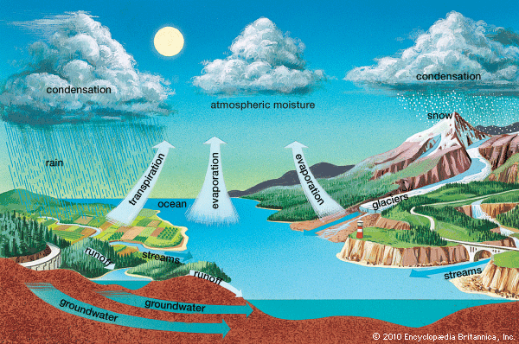

Carbon-Oxygen Cycle:

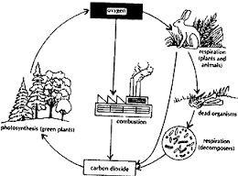

Nitrogen Cycle:

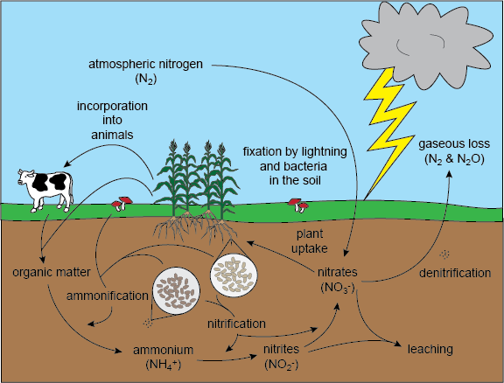

Now, go back to schoology and watch the animations for the water, carbon-oxygen, and nitrogen cycles

