Name: __________________________________

PLANT AND ANIMAL CELL

Directions: Use the organelle word list provided to fill in the blanks on the cross-sections and then complete the table by writing the functions of the organelles (tiny organs inside a cell that help it function).
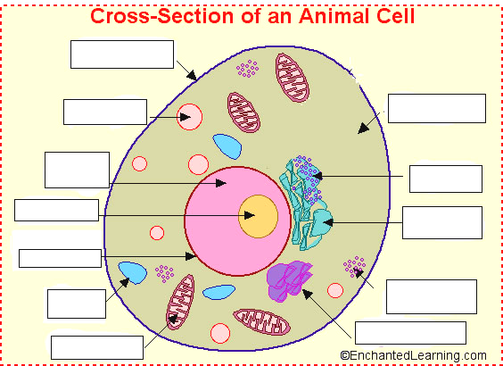

Organelle | Function
Cell Membrane | nnnnnnn
Lysosome
Cytoplasm
Nucleus
Nuclear Membrane
Nucleolus
Vacuole
Golgi Body
Mitochondrian | .
Rough E.R. | .
Smooth E.R.
Ribosome

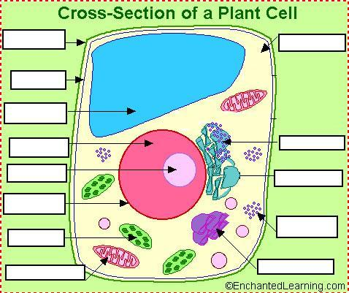

Organelle | Function
Cell Membrane
Lysosome
Cytoplasm
Nucleus
Nuclear Membrane
Nucleolus
Vacuole
Golgi Body
Mitochondrian
Rough E.R.
Smooth E.R.
Ribosome
Cell Wall
Chloroplast
What is the difference between plant and animal cells?

