Scientific Method -

- Observation – uses the senses =

- Problem/Question – always worded as a and is always
about the

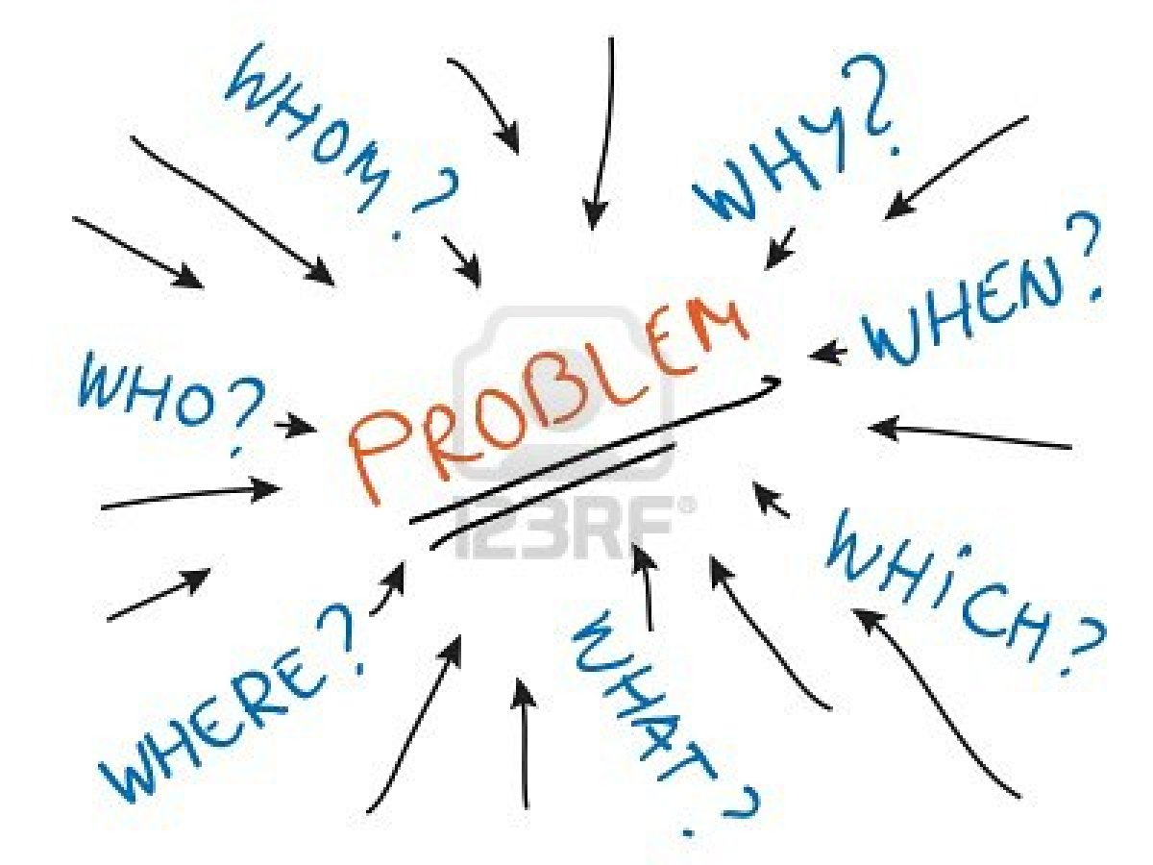
Ex.

- Research – Find out what others know about the problem

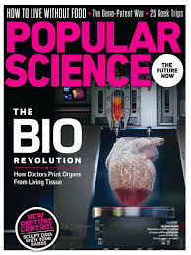

4. Hypothesis – a possible to the question ( );
must be

- If the water faucet is opened, then the amount of water flowing will increase.
- If fenders are placed on a bicycle, then the user will stay dry when going through puddles.
- If a prisoner learns a work skill while in jail, then he is less likely to commit a crime when he is released.
- If I raise the temperature of a cup of water, then the amount of sugar that can be dissolved in it will be increased.
- If there is a relation between the wave length of light and the photosynthesis rate, then light of different colors will cause the plant to make different amounts of oxygen.
- More students get sick during the final week of testing that at other times.
- One solar panel can replace one C battery.

- Worker satisfaction increases worker productivity.
- Amount of sun exposure will increase the growth of a tomato plant.
- Childhood obesity is tied to the amount of sugary drinks ingested daily.
A dog can be trained to alert a human if the telephone is ringing.

5. Experiment – a test of your and must be done many times and
by many people to the answer

Usually there are 2 groups in an experiment:
- Control Group – the normal or - and it is used to compare
to the group that has in it what you are testing;
THIS GROUP DOES NOT HAVE WHAT YOU ARE
TESTING

- Experimental Group – this is set up EXACTLY as the control group
EXCEPT it has what is being tested

- Independent Variable – the one part of the experimental
group that is different from the
from the control group
IT IS WHAT IS BEING TESTED

- Dependent Variable – the result of using the Independent
Variable

Go to: tinyurl.com/controlvsexperimental - and read this example

6. Data - the information gathered from the experiment
- put into graphs, charts and tables
a) Quantitative = anything that can be counted, measured, weighed

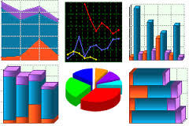

b) Qualitative = descriptions (not numbers)

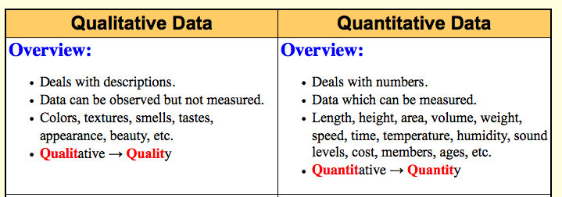

7. Analysis – interprets the info (determines what it means)

8. Conclusion – Statement that either supports (agrees with) or
refutes (disagrees with) the hypothesis

9. Theory – hypothesis that has been supported many times by
many people over many years – IT IS BELIEVED TO
BE TRUE BUT MAY CHANGE WITH NEW
INFORMATION

Examples of scientific theories are:
theory of evolution
theory of planetary motion
big bang theory
theory of the expanding universe
germ theory of disease

