Test Review: Test 2: Biochemistry and Cells

- Give 3 reasons water is important to life and tell why it is important
- The 2 elements found in all organic compounds are _______ and _________.
- Bonds are broken by ___________________ in which water is added to split the larger molecule
- Bonds are formed by __________________ in which water is subtracted from 2 molecules to put them together.
- Glucose’s formula is ____________________ and its job is to _______________________
- Match the structural formula to the correct organic compound.
Label each one
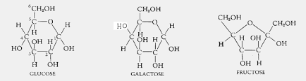
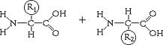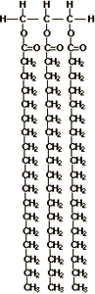

- Contrast glycogen and starch and cellulose
- Why is it better to eat foods that have a low glycemic index?
- When you look at the structure of a fatty acid, how can you tell if it is saturated or unsaturated?
- Why is the order of amino acids so important?
- How do structural and fibrous proteins differ? Name 2 proteins each can form
- How do enzymes keep us alive?
- What happens to a protein when it denatures? What is the result? What can cause it? Is it reversible?
- What is the difference between cytoplasm and cytosol?
- What 3 parts do all cells have?
- Discuss stem cell use. The different kinds, its uses, controversies, etc
- Discuss how cancer cells typically behave (progression)
- What parts do the following move through to get either in or out of a cell?
O2/CO2, glucose, H2O
- Draw a cell in a hypertonic solution. What happens to it?
- Draw a cell in a hypotonic solution. What happens to it?
- Draw a cell in an isotonic solution. What happens to it?
- Discuss the importance of the HayFlick number and how it is determined

