Transport through the Cell
- this section describes how substances get in and out of the cell

WHAT DO CELLS NEED IN ORDER TO SURVIVE?
WHAT DO CELLS NEED TO GET RID OF IN ORDER TO SURVIVE?

2 ways materials move across the membrane:
- Passive Transport – uses NO energy
- moves substances from high concentration to
low concentration (going with the concentration gradient)

DIFFUSION – the movement of particles from high to low conc.
can be made faster by:
- increasing the temperature – hot bread can be smelled across the house; more energy, faster movement
- increase the concentration – more particles hit each other
faster and therefore move faster
- increasing the pressure – stirring will move particles faster

- Simple Diffusion – moving oxygen and carbon dioxide through
the membrane
- moves through the phospholipids – Oxygen in & carbon dioxide out

- Facilitated Diffusion - moving glucose into the cell through carrier
proteins (attach to protein, it changes shape
to bring glucose in t the cell)

- Osmosis – the diffusion of WATER through a selectively permeable
Membrane
-water moves through pore/channel proteins EITHER in or out

View: How Diffusion works, Facilitated Diffusion, and Osmosis take each quiz after viewing each section

Animation- How Diffusion#185ED
Movement of water depends on the concentration of the solute in
the solution:

SOLUTION = SOLVENT (does the dissolving) + SOLUTE (substance that
Is dissolved)

Solutions = 100%, so if solute is 40%, then solvent is 60%
If solute is 10%, then solvent is _______

If a cell is 20% solute and is put into a solution that is 0% solute, what will happen to that cell?

If a cell that is 20% solute is put into a solution that is 50% solute, what will happen to that cell?

If a cell that is 20% solute is put into a solution that is 20% solute, what will happen to that cell?

II. Active Transport – uses energy to move particles across membrane
- move substances from low to high concentration
- moves against the concentration gradient

- Na-K Pump – moves these ions from low to high concentrations
- this pump uses about 1/3 of all of our energy
- this allows messages to be sent along our nerves

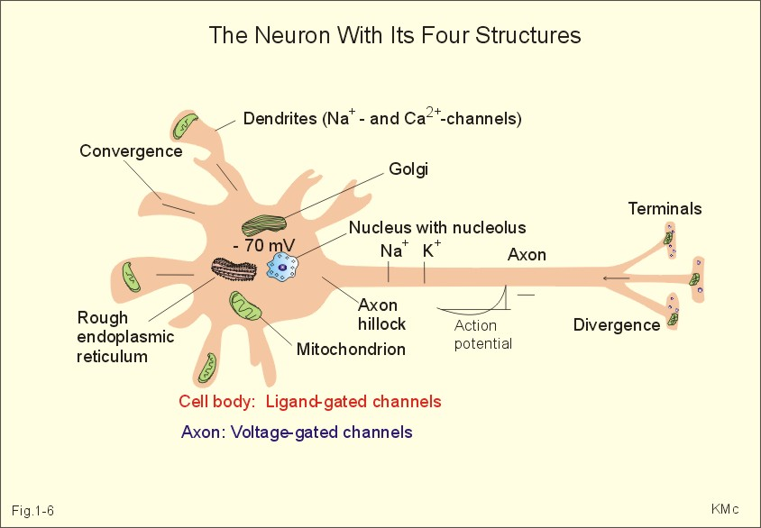

Along the axon, the pump allows a message t be received.
Once a message is sent, the pump works to return the ions to back to their side of the axon so another message can be received

- Endocytosis – bringing a particle in the cell that cannot get in
through the membrane

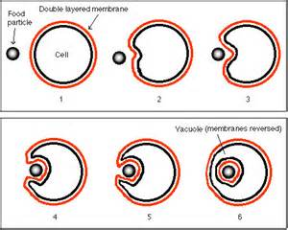

if the particle is a solid, then it is called Phagocytosis
if the particle is a liquid, then it is called Pinocytosis
- Exocytosis – to get rid of particles that cannot get out
through the cell membrane

