Unit 2: BASIC CHEMISTRY
- Defend or counter the statement: “Biology is the chemistry that works.”

- Define the following terms:
Element
Atom
Proton
Neutron
Electron
Compound
Molecule
Acid
Base
Metabolism
- What are the Four Most Common Elements in the human body?

- Label the locations and charges of the Three Subatomic Particles in an Atom:

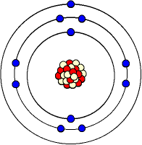

- Determine the number of protons, neutrons, and electrons for the following elements:
Element | Protons | Neutrons | Electrons
Carbon
Hydrogen
Nitrogen
Sodium
Iron
- Boron has two isotopes, B-10 and B-11. B-10 has five protons and five neutrons. What many protons and neutrons would B-11 have? Explain.

- How do compounds form? Differentiate between ionic and covalent bonding

- Determine whether the substance in an acid, base or neutral:
Vinegar |  | pH = 4.7
Ammonia |  | pH = 9.8
Bleach |  | Stomach Juices
Car Battery |  | Urine
Water |  | Blood

- What is the Most Essential Compound for living things?

- Describe and explain four important properties of water:

11. When scientists discover another planet, they look for water on or below the surface. Why?

