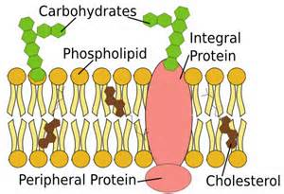
Function – selectively (semi-) permeable membrane
- lets only CERTAIN substances pass through
- is a boundary between intracellular and
extrcellular environments
- helps to maintain HOMEOSTASIS between the
inside and the outside of the cell

The Cell/Plasma membrane is referred to as the FLUID MOSAIC MODEL
Fluid – because all the parts can move around, they are not stuck
in place, nor ate they rigid
Mosaic – because proteins are dotted throughout the membrane

- Phospholipids –a bilayer of phosphate heads and lipid tails
- Phosphate Heads – are hydrophilic (they LOVE water and are attracted to it) because they are polar (polar attracts polar)
HOW DOES WATER BEHAVE WITH OTHER WATER?

- Lipid tails – they are hydrophobic (they HATE water and are repelled by it) because they are nonpolar

HOW DO WATER AND OIL BEHAVE WITH EACH OTHER?

- Proteins – several different kinds that are dotted throughout the membrane
- Integral/Transmembrane – go through both layers of phospholipids
- Channel/Pore - open all the time ; lets water pass through in/out
- Carrier – changes shape to let substances in/out; glucose, ions,
a.a., etc

3. Receptor – receives messages and sends them inside; ex insulin –
attaches to a receiver protein and sends the message in
to the cell to take in glucose (out of blood and in to
cell, thus lowering blood sugar)

B. Peripheral – do not go all the way through but extend to the outside
or inside
May have carbohydrates attached to outside ones –this
Act as an identifier of what belongs in the body
WHY IS IT NECESSARY FOR A CELL TO IDENTIFY WHAT BELONGS
IN THE BODY?

- Cholesterol - helps to keep lipid tails from sticking together
- without cholesterol, membrane would collapse

