Web Quest –Cell Specialization

PART I: CELL SPECIALIZATION (STRUCTURE & FUNCTION ARE RELATED)
Go To: http://www.neok12.com/Cell-Structures.htm
Watch the video called: “Specialized Cells and Tissues”. Complete the related facts:

Epidermal cells are found in the _______________.
Muscle cells are long and _____________-like and contain ___________________.
The muscle cells _______________ and _________________ together making movement possible.
Bone cells secrete ___________________ which forms bone.
Nerve cells, also called ________________, conduct _____________________.
Label the structures of the nerve cell:
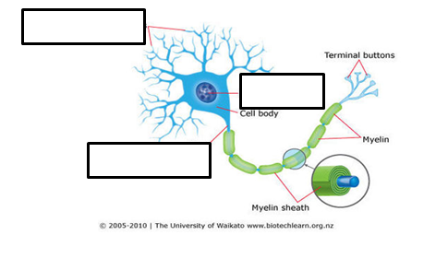

There are several kinds of blood cells.
Red Blood Cells are most numerous. They carry ________________.
White Blood Cells defend body against _______________________.

Go To: http://www1.ccs.k12.in.us/teachers/downloads/cms_block_file/50931/file/51165
Complete the related facts:

The process in which a cell becomes specialized is called ____________________ and occurs when the cell selectively activates or inactivates specific ____________.
The specialized cells of an organism contain the exact same complement of genes. In humans, this means that each cell type contains approximately _____________ genes. This is because each cell is the descendent of a single cell, the __________________ _______________.

Melanocytes are specialized skin cells located in the ____________ layer of the epidermis.
They produce and secrete ___________________ which gives skin its color.
Melanocytes contain unique structures called _______________________ where melanin is produced. The enzyme ___________________ catalyzes production of melanin.

Red blood cells are specialized cells of the ____________________ system. RBCs have a unique shape because they lose their _________________ to make room for hemoglobin, a large protein that carries ____________________.
RBCs come from ___________________________ cells, or adult stem cells, in the bone marrow. Your body replaces _______________________ RBCs every second.
RBCs never divide. Old cells are removed, after about 120 days, by the _____________ and ___________________.

Sperm cells are part of the _______________________ system. Their function is to ____________________________________________________________.
The sperm cell contains an ______________________________ which contains digestive enzymes that allow it to penetrate the ovum. It also contains a ___________________ which allows it to move toward the ovum.

______________________ are fat cells located under the skin. These cells have 3 functions:

1.

2.

3.

PART II: STEM CELLS-WHERE IT ALL BEGINS!
Go To: http://stemcells.nih.gov/info/basics/Pages/Default.aspx
Select: Introduction: What are stem cells, and why are they important?

Stem cells have the __________________to develop into any of the cell types in the body during early life and growth. In many tissues they serve as a sort of _____________ _______________ ______________, dividing without limit to replenish other cells. When a stem cell divides, each new cell has the potential either to ____________ __ ________________ ____________ or become another type of cell with a more ______________ ___________________, such as a muscle cell, a red blood cell, or a brain cell.

In the newly formed embryo, at the blastocyst stage, embryonic stem cells differentiate into all of the specialized cell types in the body such as: ____________, __________________, ________________, ___________________, ___________________, and other ____________________.

Adult stem cells are found in adult tissues such as ___________ ________________, ___________________, and ______________ and generate ________________________ for cells that are injured, old, or sick.

PART IV: PLANT CELL SPECIALIZATION (PLANTS ARE SPECIAL TOO!)
Go To: http://www.accessexcellence.org/
Select: Graphics Gallery
Select: Plant Cells and Tissues Part 2

________________ tissue is the primary outer covering of the plant body. __________________ cells have thick outer walls and are covered with a waxy _________________ which protects the plant from injury. _________________ cells regulate the opening of the stomata which allows gas exchange in plant leaves.

Parenchyma, collenchyma, and sclerenchyma, sieve tube elements, companion cells, and vessel elements are all part of the ________________ and ________________ tissues which are vascular tissues that conduct water and organic solutes throughout the plant body.

